The One With the Blackout
107 停电
纽约全城停电。
钱德碰巧被困在一间24小时ATM自助服务厅里，
名模吉儿碰巧也被困当中。
钱德有心无胆，空欢喜一场。
其余五人呆在莫妮卡和瑞秋家。
丑陋裸男点了很多蜡烛。
罗斯决心向瑞秋表白时遭到一只猫的攻击。
瑞秋和菲比替猫找寻主人，遇到“怪人”海先生。
他声称他就是猫的主人，但显然他在撒谎。
原来猫的主人叫保路，是这栋楼里居住的意大利大块头男人，他不大会讲英语。
瑞秋和保路一见钟情，打得火热。
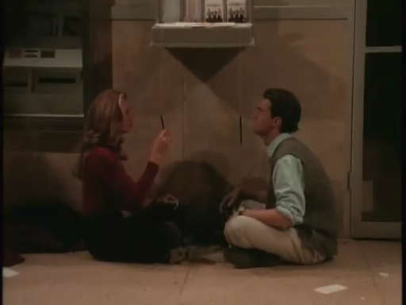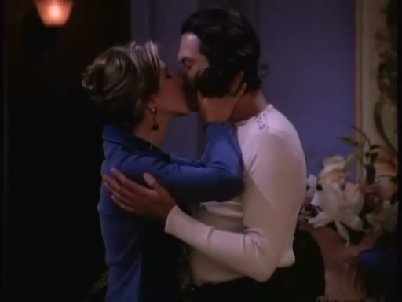
1.07 The One With the Blackout
New York City is blacked out (due to a mishap[n.灾祸] on Mad About You).
Chandler is trapped in an ATM vestibule with Jill Goodacre.
The rest of the gang hangs out at Monica and Rachel's apartment.
Ugly Naked Guy lights a bunch of candles and has a slight accident.
While trying to share his feelings with Rachel, Ross is attacked by a cat.
While searching for the cat's owner, Rachel and Phoebe meet "the Weird Man", known in later episodes as Mr. Heckles.
He tries to claim the cat, but it obviously isn't his.
The cat turns out to belong to Paolo, an Italian hunk who lives in the building and doesn't speak much English.

[Scene: Central Perk, Rachel is introducing Phoebe, who is playing her guitar for the crowd.]
Rachel: Everybody? Shh, shhh. Uhhh... Central Perk is proud to present the music of Miss Phoebe Buffay.
present vt.引见 上演
(applause)
Phoebe: Hi. Um, I want to start with a song that's about that moment when you suddenly realize what life is really all about. OK, here we go. (plays a chord, then the lights go out) OK, thank you very much.
chord n.和音/go out v.熄灭
[Scene: The ATM vestibule of a bank, Chandler is inside. The lights go out, and he realizes he is trapped inside.]
ATM n.Automatic Teller Machine自动取款机/vestibule n.门廊 前厅[eg:I have to ask David to wait in the vestibule]
Chandler: Oh, great. This is just...
(Chandler sees that there is a gorgeous model inside the vestibule with him. He makes a gesture of quiet exuberance.)
exuberance n.生气勃勃的行动/quiet exuberance n.暗喜/Jill Goodacre Connick (born March 29, 1965 in Lubbock, Texas) is a fashion model who appeared extensively in the 1990s Victoria's Secret catalogs. After directing one of his music videos in 1992, Goodacre married Harry Connick, Jr., in 1994. She is the daughter of real estate broker William Goodacre of Boulder, CO and Glenna N. Goodacre, a native of Lubbock, Texas, who resides in Santa Fe, New Mexico. Her mother is now married to Dallas attorney Michael Lee "Mike" Schmidt.She has three daughters with Connick: Georgia Tatom (born April 17, 1996), Sarah Kate (September 12, 1997), and Charlotte (born June 26, 2002).


Opening Credits
[Scene: Monica and Rachel's, Monica is on the phone with her mother. Phoebe, Rachel, and Ross are there.]
Rachel: Wow, this is so cool, you guys. The entire city is blacked out!
black out v.停电
Monica: Mom says it's all of Manhattan, parts of Brooklyn and Queens, and they have no idea when it's coming back on.
Rachel: Wow, you guys, this is big.
Monica: (into phone) Pants and a sweater? Why, mom? Who am I gonna meet in a blackout? Power company guys? Eligible looters? Could we talk about this later? OK. (hangs up)
power company n.电力公司/looter n.打劫者/eligible adj.(尤指婚姻等)合适的 合意的[eg:Helen married an eligible bachelor]
Phoebe: Can I borrow the phone? I want to call my apartment and check on my grandma. (to Monica) What's my number?
(Monica and Rachel look at Phoebe strangely.)
Phoebe: Well, I never call me.
[Scene: ATM vestibule, Jill Goodacre is on the cellular phone.]
cellular phone n.手机
Chandler: Oh my God, it's that Victoria's Secret model. Something... something Goodacre.
Victoria's Secret is an American retailer of high quality lingerie and beauty products.It is the largest brand and a segment of publicly traded Limited Brands with sales surpassing $5 billion and an operating income(n.营业收入) of US$1 billion in 2006.Victoria's Secret is well known for its fashion shows and catalogues, which feature top fashion models such as Adriana Lima and Alessandra Ambrosio.

Jill: (on phone) Hi Mom, it's Jill.
Chandler: She's right, it's Jill. Jill Goodacre. Oh my God. I am trapped in an ATM vestibule with Jill Goodacre! (pause) Is it a vestibule? Maybe it's an atrium. Oh, yeah, that is the part to focus on, you idiot!
vestibule n.前厅/atrium n.中厅
Jill: (on phone) Yeah, I'm fine. I'm just stuck at the bank, in an ATM vestibule.
Chandler: Jill says vestibule... I'm going with vestibule.
Jill: (on phone) I'm fine. No, I'm not alone... I don't know, some guy.
Chandler: Oh! Some guy. Some guy. 'Hey Jill, I saw you with some guy last night. Yes, he was some guy.
(Chandler strides proudly across the vestibule and Jill stares at him.)
stride v.大步行走
[Scene: Monica's apartment, Joey enters with a menorah, the candles lit.]
menorah n.(犹太教)七/九灯的烛台

Joey: Hi everyone.
Ross: And officiating at tonight's blackout, is Rabbi Tribbiani.
officiate v.主持(宗教仪式)/rabbi n.拉比(犹太人的学者)
Joey: Well, Chandler's old roomate was Jewish, and these are the only candles we have, so... Happy Chanukah, everyone.
Jewish adj.犹太族的/Chanukah n.光明节(犹太人一纪念节日)/光明节与九座烛台:光明节为期八天，约在每年十二月初，是为了纪念当初犹太祖先夺回耶路撒冷圣殿，当时在圣殿献灯的灯油，原本只能燃烧一天，最后却燃烧了八天的奇迹。犹太人会从光明节第一天起，在九座烛台上依次由右至左，一天插上一支蜡烛，直到第八天八根蜡烛一起为止，而中央的蜡烛则是专供引火之用。过节期间，亲友都会团聚一堂，目睹点燃烛火并一起祷告。而Joey 把这些具有宗教意义的烛台点燃，只为了应付停电之需，跟它本身神圣的意义形成强烈的对比，所以Ross 才开玩笑称他为“犹太教士（拉比）”Rabbi。
Phoebe: (at window) Eww, look. Ugly Naked Guy lit a bunch of candles.
(They all look at the window, grossed out, then flinch in pain.)
gross out v.使(人)作呕 惹人讨厌[eg:His dirty jokes grossed me out]/flinch vi.畏缩 退缩
Rachel: That had to hurt!
[Scene: ATM vestibule.]
Chandler: Alright, alright, alright. It's been fourteen and a half minutes and you still have not said one word. Oh God, do something. Just make contact, smile!
(Chandler smiles at her, she smiles back sweetly.)
Chandler: There you go!
(He continues to smile like an idiot, and she looks frightened.)
Chandler: You're definitely scaring her.
Jill: (awkwardly) Would you like to call somebody? (offering phone)
Chandler: Yeah, about 300 guys I went to high school with. Yeah, thanks. (takes phone)
[Scene: Monica and Rachel's, The phone rings; it's Chandler.]
Monica: Hello?
Chandler: Hey, it's me.
Monica: (to everyone) It's Chandler! (on phone) Are you OK?
Chandler: Yeah, I'm fine. (trying to cover up what he is saying) I'm trppd in an ATM vstbl wth Jll Gdcr.
Monica: What?
Chandler: I'm trppd... in an ATM vstbl... wth Jll Gdcr!
Monica: I have no idea what you just said.
Chandler: (angry) Put Joey on the phone.
Joey: What's up man?
Chandler: I'm trppd... in an ATM vstbl... wth JLL GDCR.
Joey: (to everyone) Oh my God! He's trapped in an ATM vestibule with Jill Goodacre! (on phone) Chandler, listen. (says something intentionally garbled)
intentionally adv.故意地/garble vt.曲解
Chandler: Yeah, like that thought never entered my mind.
[Scene: Monica and Rachel's, time has passed. The five are sitting around the coffee table talking.]
Rachel: Alright, somebody.
Monica: OK, I'll go. OK, senior year of college... on a pool table.
senior n.大四/pool n.撞球/pool table n.有六个落袋的撞球台/Monica: OK, I'll go. OK, senior year of college... on a pool table.常常在英语角碰到人介绍自己时候说是Grade one or two之类的，其实大学几年级有更地道的说法，freshman->一年级，sophomore->二年级，junior->三年级，senior->大四，研究生是postgraduate,博士生是phd，还有人往往介绍自己直博了，个人认为如下说法比较合适:be nominated to be a phd candidate directly,在有些学校介绍硕博连读的网页上，还有如下表述direct-promotion program for PHD diploma..还常常有ABD来代表在读的博士生或者准博士。值得注意的是国外大学一般很少有授予硕士学位，不像国内。
All: Whoooaa!
Ross: That's my sister.
Joey: OK... my weirdest place would have to be... the women's room on the second floor of the New York City public library.
the women's room n.女厕所/The New York Public Library (NYPL) is one of the leading public libraries of the world and is one of America's most significant research libraries(n.专供学者与专家做深入研究的图书馆). It is unusual in that it is composed of a very large circulating public library system combined with a very large non-lending(adj.不出借书刊资料) research library system. It is simultaneously one of the largest public library systems in the United States and one of the largest research library systems. It is a privately managed, nonprofit corporation with a public mission, operating with both private and public financing. Its flagship building, on Fifth Ave. running from 40th to 42nd Street in Manhattan, is a National Historic Landmark.The historian David McCullough has described the New York Public Library as one of the five most important libraries in America, the others being the Library of Congress, the Boston Public Library, and the university libraries of Harvard and Yale.Although it is called the New York Public Library it does not cover all five boroughs of America's largest city. New York City does not have a single public library system but three of them. The other two are the Brooklyn Public Library and the Queens Borough Public Library.Currently, the New York Public Library consists of 86 libraries in the Bronx, Manhattan, and Staten Island: four non-lending research libraries, four main lending libraries, a library for the blind and physically handicapped, and 77 neighborhood branch libraries. All libraries in the NYPL system may be used free of charge by all visitors.
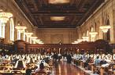
Monica: Oh my God! What were you doing in a library?
Ross: Pheebs, what about you?
Phoebe: Oh... Milwaukee.
Rachel: Um... Ross?
Ross: Disneyland, 1989, 'It's a Small World After All.'
It's a Small World (formatted “it's a small world” by the Walt Disney Company) is a popular attraction at several Walt Disney theme parks: Disneyland (in California), the Magic Kingdom (in Florida), Tokyo Disneyland, and Disneyland Resort Paris. It has been announced that it will open in Hong Kong Disneyland in 2008. The ride features a multitude of audio-animatronic figures in the style of children of the world singing the ride's title track (composed by the Sherman Brothers), which has a theme of global peace/It's a Small World After All:这是迪斯尼乐园“奇幻王国”的一个旅游项目“小世界”，人们坐着船顺着水道漂行，岸两边有机械控制的小人载歌载舞，服装和背景反映世界各国的风貌。剧中罗斯回忆自己最古怪的做爱地点时选择了这里，1989年他和卡罗尔去迪斯尼，因为机械故障，“小世界”停了下来，罗斯就和卡罗尔爬到一群荷兰小人后面去做爱，但就在这个过程中，机械故障被修好了。结果是：罗斯和卡罗尔成为“奇幻王国”不受欢迎的人，被要求再也不许去那里玩。
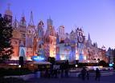
All: No way!
Ross: The ride broke down. So, Carol and I went behind a couple of those mechanical Dutch children... then they fixed the ride, and we were asked never to return to the Magic Kingdom.
Dutch adj.荷兰的/The Magic Kingdom is a theme park within the Walt Disney World Resort in Lake Buena Vista, Florida, near Orlando. It is owned and operated by The Walt Disney Company through its Walt Disney Parks and Resorts unit. Opened on October 1, 1971, it is the most famous Florida theme park. Designed and built by WED Enterprises (now known as Walt Disney Imagineering), the park's layout and attractions are similar to Disneyland Park in Anaheim, California, which opened in 1955. It saw 16,640,000 guests in 2006 making it the most visited theme park in the world.
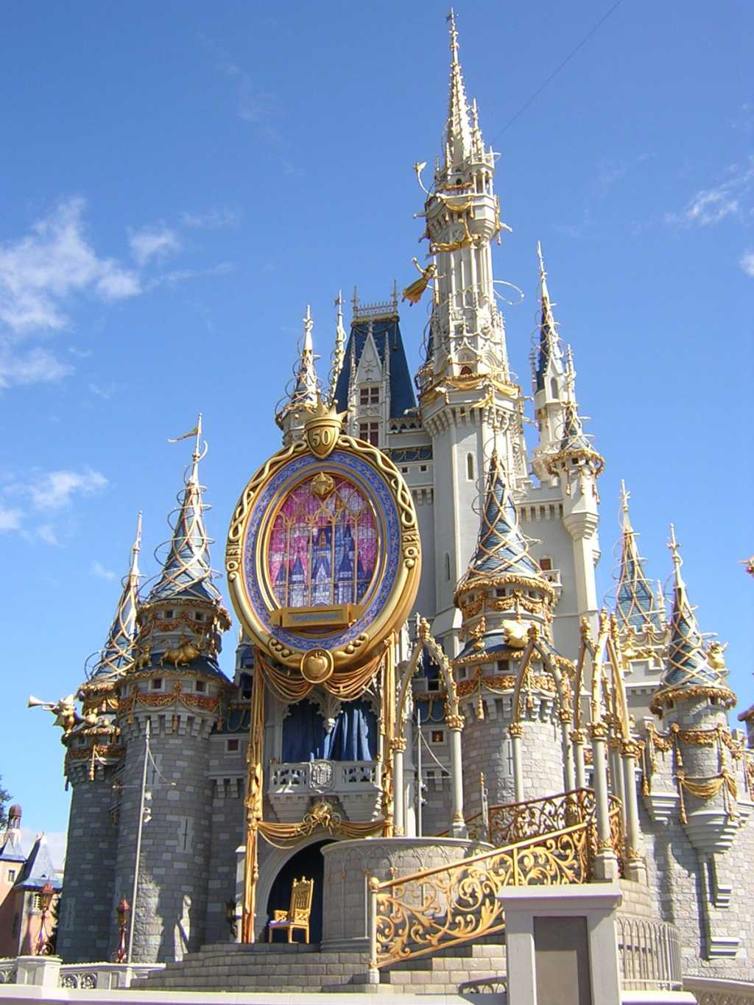
Phoebe: Oh, Rachel.
Rachel: Oh come on, I already went.
Monica: You did not go!
All: Come on.
Rachel: Oh, alright. The weirdest place would have to be... (sigh)... oh, the foot of the bed.
Ross: Step back.
step back v.退后
Joey: We have a winner!
[Time lapse, Ross and Rachel are talking, Joey is on the couch, and Monica and Phoebe are out of the room.]
Rachel: I just never had a relationship with that kind of passion, you know, where you have to have somebody right there, in the middle of a theme park.
theme park n.主题乐园
Ross: Well, it was the only thing to do there that didn't have a line.
line n.等候线
Rachel: There, well, see? Barry wouldn't even kiss me on a miniature golf course.
miniature golf n.小小高尔夫球
miniature golf course
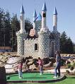
Ross: Come on.
Rachel: No, he said we were holding up the people behind us.
hold up v.阻挡
Ross: (sarcastically) And you didn't marry him because...?
Rachel: I mean, do you think there are people who go through life never having that kind of...
Ross: Probably. But you know, I'll tell you something. Passion is way overrated.
overrate v.过高估计/way adv.远远地
Rachel: Yeah right.
Ross: It is. Eventually, it kind of... burns out. But hopefully what you're left with is trust, and security, and... well, in the case of my ex-wife, lesbianism. So, you know, for all of those people who miss out on that passion... thing, there's all that other good stuff.
eventually adv.最终/burn out v.烧尽/security n.安全感/lesbianism n.女同志主义/miss out v.遗漏
Rachel: (sigh) OK.
Ross: But, I don't think that's gonna be you.
Rachel: You don't.
Ross: See, I see.... big passion in your future.
Rachel: Really?
Ross: Mmmm.
Rachel: You do?
Ross: I do.
Rachel: Oh Ross, you're so great. (she playfully rubs his head and gets up)
playfully adv开玩笑地/rub v.摩擦
(Ross gets up, pleased with himself.)
Joey: It's never gonna happen.
Ross: (innocently) What?
innocently adv.无罪地
Joey: You and Rachel.
Ross: (acts surprised) What? (pause) Why not?
Joey: Because you waited too long to make your move, and now you're in the friend zone.
Ross: No, no, no. I'm not in the zone.
Joey: Ross, you're mayor of the zone.
mayor n.市长
Ross: I'm taking my time, alright? I'm laying the groundwork. Yeah. I mean, every day I get just a little bit closer to...
take one's time vt.从容不迫 慢慢来/groundwork n.基础 根基
Joey: Priesthood! Look Ross, I'm telling you, she has no idea what you're thinking.If you don't ask her out soon,you're going to end up stucking in the zone forever.
priesthood n.教士 神父/end up doing v.以……告终
Ross: I will, I will. See, I'm waiting for the right moment. (Joey looks at him) What? What, now?
Joey: Yeeeeaaaahhh! What's messing you up? The wine? The candles? The moonlight? You've just got to go up to her and say, 'Rachel, I think that...' (Rachel comes into the room behind them)
mess up v.搞糟 陷入困境
Ross: Shhhh!
Rachel: What are you shushing?
shush v.n.嘘
Ross: We're shushing... because... we're trying to hear something. Listen. (everyone is silent) Don't you hear that?
Rachel: Ahhhh!
Ross: See?
Rachel: Huh. (she agrees, but looks very confused)
[Scene: ATM vestibule.]
Jill: Do you like some gum?
gum n.口香糖
Chandler: Um, is it sugarless?
Jill: (checks) Sorry, it's not.
Chandler: Oh, then no thanks. What the hell was that? Mental note: If Jill Goodacre offers you gum, you take it. If she offers you mangled animal carcass, you take it.
mangle vt.乱砍 撕裂/carcass n.(屠宰后)畜体
[Scene: Monica's apartment, Phoebe is singing.]
Phoebe: (singing) New York City has no power, and the milk is getting sour. But to me it is not scary, 'cause I stay away from dairy.... la la la, la la, la la... (she writes the lyrics down)
sour adj.发酸的/stay away from v.远离/dairy n.奶制品/lyrics n.歌词
Ross: (to Joey) OK, here goes.
Joey: Are you gonna do it?
Ross: I'm gonna do it.
Joey: Do you want any help?
Ross: You come out there, you're a dead man.
Joey: Good luck, man.
Ross: Thanks. (Joey hugs him) OK.
Joey: OK. (Ross goes out on the balcony to talk to Rachel)
(Monica walks in, starts to go out on the balcony.)
Joey: Hey, where are you going?
Monica: Outside.
Joey: You can't go out there.
Monica: Why not?
Joey: Because of... the reason.
Monica: And that would be?
Joey: I, um, can't tell you.
Monica: Joey, what's going on?
Joey: OK, you've got to promise that you'll never ever tell Ross that I told you.
Monica: About what?
Joey: He's planning your birthday party.
Monica: Oh my God! I love him!
Joey: (as Phoebe enters) You'd better act surprised.
Phoebe: About what?
Monica: My surprise party!
Phoebe: What surprise party?
Monica: Oh stop it. Joey already told me.
Phoebe: Well, he didn't tell me.
Joey: Hey, don't look at me. This is Ross's thing.
Phoebe: This is so typical. I'm always the last one to know everything.
Monica: No, you are not. We tell you stuff.
Phoebe: Yuh-huh! I was the last one to know when Chandler got bitten by the peacock at the zoo. I was the last one to know when you had a crush on Joey when he was moving in. (Monica gestures at Phoebe to shut up; Joey looks surprised but pleased) Looks like I was second to last.
peakcock n.孔雀/gesture at sb to do示意某人做某事/second to last n.倒数第二
[Scene: Monica and Rachel's Balcony, Ross and Rachel are talking.]
Rachel: Hmmm... this is so nice.
Ross: OK, I have a question. Well, actually, it's not so much a question as.. more of a general wondering... ment.
more of a general wondering 更像是普通的好奇
Rachel: OK.
Ross: OK. Here goes. For a while now, I've been wanting to, um....
Rachel: Ohhh!!!! (looking at something behind Ross)
Ross: Yes, yes, that's right...
Rachel: Oh, look at the little cat! (a small kitten is on the roof behind Ross)
Ross: What? (the cat jumps on his shoulders) Ow!
[Cut to inside. Monica, Joey and Phoebe are singing while outside, Ross and Rachel are trying to get the cat off of Ross' shoulder.]
Monica, Joey, and Phoebe: (singing) I'm on top of the world, looking down on creation and the only explanation I can find, is the wonders I've found ever since...
on top of the world adv.<口>幸福到极点

Commercial Break
[Scene: Monica and Rachel's, Phoebe is holding the cat, Monica is treating the scratches on Ross' back. Joey is holding the menorah over the wound.]
Monica: (to Ross) This is just Bactine. It won't hurt.
Bactine is the trademarked name of a range of topical first aid treatments produced by Bayer. It includes a first aid liquid with active ingredients(n.活性成份) Benzalkonium chloride(n.杀藻胺), an antiseptic(adj.杀过菌的), and lidocaine[n.利多卡因(一种局部麻醉剂)], a local anaesthetic(n.麻醉剂). Bactine Liquid is a topical anesthetic, (a type of local anesthetic) which means that it is used to numb the surface of a body part.肌乐。拜尔公司出产的伤口急救喷雾剂
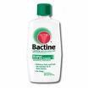
(Ross flinches in pain.)
Joey: Sorry, that was wax.
wax n.蜡
Phoebe: Oh, poor little Tooty is scared to death. We should find his owner.
tooty<俚>pussy
Ross: Why don't we just put 'poor little Tooty' out in the hall?
Rachel: During a blackout? He'd get trampled!
trample v.践踏
Ross: (nonchalantly) Yeah?
nonchalantly adv.漠不关心地 冷淡地
[Scene: ATM vestibule.]
Chandler: You know, on second thought, gum would be perfection. (Jill gives him a stick of gum, and a strange look) 'Gum would be perfection'? 'Gum would be perfection.' Could have said 'gum would be nice,' or 'I'll have a stick,' but no, no, no, no. For me, gum is perfection. I loathe myself.
second thought adv.重新考虑/perfection n.绝佳的选择/a stick of gum一片口香糖/loathe vt.憎恨 厌恶
[Scene: The hallway of Monica's building. Phoebe and Rachel are trying to find the cat's owner.]
hallway n.走廊
Phoebe: (stops at a door) Oh no, the Mendels, they hate all living things, right?
Rachel: Oh. (they knock at the next door, Mr. Heckles answers) Hi. We just found this cat and we're looking for the owner.
Mr. Heckles: Er, yeah, it's mine.
Phoebe: (trying to hold back the struggling cat) He seems to hate you. Are you sure?
Mr. Heckles: Yeah, it's my cat. Give me my cat.
Phoebe: Wait a minute. What's his name?
Mr. Heckles: Ehhhh... B-Buttons.
Rachel: Bob Buttons?
Mr. Heckles: Mmm. Bob Buttons. Here, Bob Buttons.
Phoebe: (the cat runs away from her) Oooh! You are a very bad man!
Mr. Heckles: (as Phoebe and Rachel leave) You owe me a cat.
[Scene: Rachel has gone off on her own to look for the cat's owner.]
Rachel: Here, kitty-kitty. Here kitty-kitty. Where did you go, little kitty-kitty-kitty? Here kitty-kitty-kitty-kitty...
(While looking at the floor for the cat, Rachel runs into a pair of legs. She slowly gets up and sees a gorgeous Italian hunk holding the cat. Who, by the way, you'll hate very, very soon. The man. Not the cat.)
run into v.撞上/hunk <俚>强壮 英俊且性感的男人[eg:Most girls wish they could meet a sensitive hunk, with brains]
Paolo: (something Italian)
Rachel: Wow. (she exhales in amazement, blowing the candle out)
exhale v.呼气/blow out v.吹熄
[Scene: Monica and Rachel's, Ross, Monica, and Joey are playing Monopoly.]
Ross: (rolling) Lucky sixes....
Rachel: (entering with Paolo, arm in arm) Everybody, this is Paolo. Paolo, I want you to meet my friends. This is Monica.
Monica: (smitten) Hi!
smite v.重击 使神魂颠倒
Rachel: And Joey....
Monica: Hi!
Rachel: And Ross.
Monica: Hi!
Paolo: (something in Italian)
Rachel: (proudly) He doesn't speak much English.
Paolo: (pointing at game) Monopoly!
Rachel: Look at that!
Ross: (jealous) So, um... where did Paolo come from?
Rachel: Oh... Italy, I think.
Ross: No, I mean tonight, in the building. Suddenly into our lives.
Rachel: Well, the cat... the cat turned out to be Paolo's cat!
Ross: That, that is funny... (to Joey).... and Rachel keeps touching him.
(Phoebe enters.)
Phoebe: Alright. I looked all over the building and I couldn't find the kitty anywhere.
Rachel: Oh, I found him. He was Paolo's cat.
Phoebe: Ah! Well! There you go! Last to know again! And I'm guessing... since nobody told me... this is Paolo.
Rachel: Ah, Paolo, this is Phoebe.
Paolo: (something in Italian, he is apparently attracted to Phoebe)
Phoebe: (smiling) You betcha!
betcha <口>当然
[Scene: ATM vestibule.]
Chandler: (chewing gum) Ah, let's see. What next? Blow a bubble. A bubble's good. It's got a... boyish charm, it's impish. Here we go.
impish adj.顽皮的
(Chandler waits until Jill is looking, then starts to blow a bubble. But instead of blow one, he accidentally spits the gum out of his mouth and hits the wall.)
Chandler: Nice going, imp. OK, it's OK. All I need to do is reach over and put it in my mouth. (Chandler slyly grabs the gum from the wall and slides it back in his mouth.)
imp n.小鬼 顽童/slyly adv.秘密地
Chandler: Good save! We're back on track, and I'm... (grimacing) ..chewing someone else's gum. This is not my gum. Oh my God! Oh my God! And now you're choking.
grimace vi.作苦相
(Chandler starts to choke.)
Jill: Are you alright?
(Chandler tries to save face and makes the 'OK' sign with his hands, while obviously unable to breathe.)
Jill: My God, you're choking! (she runs over and gives him the Heimlich, the gum flies from his mouth) That better?
Heimlich maneuver is an emergency technique used to eject an object, such as food, from the trachea(n.气管) of a choking person. The technique employs a firm upward thrust(n.推力) just below the rib cage(n.胸腔) to force air from the lungs up through the trachea, thus dislodging(v.撞出) the obstruction(n.阻塞物)<医>海姆利克氏操作法/还记得上次介绍的maneuver么，Heimlich就是医生们的一个maneuver ，海姆利克氏操作法，Heimlich手法具体操作方法如下：当患者突然发生呼吸道异物导致窒息时，立即使其弯腰前倾，术者立于患者背后，两手合拢抱住患者，其中一手握拳，在患者上腹部用力猛的向上提，借助胃泡内及肺内残留气体被挤出时产生的推力和患者上半部躯体倒悬时产生的对异物的重力，将气管内或卡在会厌部位的异物推出，从而挽救患者的生命。Heimlich情急之中无意间发明此法，第一位获救者是他的妻子，目前此法在美国已家喻户晓，常组织有数万人参加的演练。这里Jill就用这种方法救了Chandler一命。
Chandler: (gasping) Yes... thank you. That was... that was....
Jill: Perfection?
[Scene: Monica and Rachel's, Rachel and Paolo are at the window. Ross and Joey are watching disgustedly.]
Paolo: (something romantic in Italian about Rachel and the stars)
Ross: (mocking Paolo) Blah blah blah, blah blah blah... blah blaaaaaah....
(Rachel walks away from Paolo, laughing.)
Ross: What did he say that was so funny?
Rachel: I have absolutely no idea.
Ross: That's... that's classic.
Rachel: (to Monica and Phoebe) Oh my God, you guys, what am I doing? What am I doing? This is so un-me!
Monica: If you want, I'll do it.
(Ross looks at Joey.)
Phoebe: I know, I just want to bite his bottom lip. (Rachel looks at her) But I won't.
Rachel: God, the first time he smiled at me... those three seconds were more exciting than three weeks in Bermuda with Barry.
Bermuda n.百慕大群岛(北大西洋西部群岛)
Phoebe: You know, did you ride mopeds? 'Cause I've heard... (they stare at her)... oh, I see... it's not about that right now. OK.
moped n.机动脚踏两用车
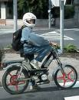
Rachel: Y'know, I know it's totally superficial and we have absolutely nothing in common, and we don't even speak the same language but Goooooooddddddd....
superficial adj.肤浅的 浅薄的
[Cut to the other side of the apartment, Ross has gone over to straighten things out with Paolo.]
straighten v.(使)变直 (使)变平整/straighten out v.澄清(=clarify)
Ross: Paolo. Hi.
Paolo: Ross!
(Ross notices that Paolo is standing on a step, which makes him taller. Ross gets up on the same step so he can look down at Paolo.)
Ross: Listen. Um, listen. Something you should... know... um, Rachel and I... we're kind of a thing.
Paolo: Thing?
Ross: Thing, yes. Thing.
Paolo: Ah, you... have the sex?
Ross: No, no, no. Technically the... sex is not... being had, but that's... see, that's not the point. See, um, the point is that... Rachel and I should be together. You know, and if you get in the.... um...
Paolo: Bed?
Ross: No, no, that's not where I was going. Er, if you get in the... way, of us becoming a thing, then I would be, well, very sad.
get in the way v.妨碍
Paolo: Oh!
Ross: Yeah! Se vice?
Paolo: Si.
Ross: So you do know a little English.
Paolo: Poco... a leetle.
Ross: Do you know the word crapweasel?
crapweasel n.白痴 浑蛋
Paolo: No.
Ross: That's funny, because you know, you are a huge crapweasel!
(They hug.)
[Scene: ATM vestibule, Chandler and Jill are sitting below the counter with two pens dangling from their chains in front of them. Jill is showing Chandler how to swing the pen around his head.]
dangle v.摇摆 悬荡
Jill: Chandler, we've been here for an hour doing this! Now watch, it's easy.
Chandler: OK.
Jill: Ready? (she swings the pen around her head in a circle)
in a circle adv.作环状
(Chandler tries to do the same thing but the pen hits him in the head.)
Jill: No, you've got to whip it.
whip v.鞭打 抽打
(He swings the pen hard, and it snaps back and almost hits him again.)
snap back v.迅速弹回
[Scene: Monica and Rachel's, the gang is all sitting around the table.]
Phoebe: Oh, look look look. The last candle's about to burn out. 10, 9, 8, 7... (time lapse)... minus 46, minus 47, minus 48.... (someone blows it out, the room gets completely dark)
minus adj.负的
Ross: Thank you.
Phoebe: Thanks.
Ross: Kinda... spooky without any lights.
spooky adj.吓人的 幽灵般的 怪异的
Joey: (does a maniacal laugh) Bwah-hah-hah!
maniacal adj.发狂的 狂乱的
(Everyone starts to imitate him.)
Ross: OK, guys, guys? I have the definitive one. Mwwwooooo-hah-hah...
definitive adj.决定性的 最后的
(The lights come back on, and Rachel and Paolo are making out. Ross clutches his chest.)
make out <口>亲热
Ross: Oh.. oh... oh.
Joey: Hey Ross. This probably isn't the best time to bring it up, but you have to throw a party for Monica.
bring up v.提出

Closing Credits
[Scene: ATM vestibule, the power has come back on.]
Jill: Well, this has been fun.
Chandler: Yes. Yes, thanks for letting me use your phone... and for saving my life.
Jill: Well, goodbye Chandler. I had a great blackout. (she kisses him on the cheek) See ya.
(She leaves. Chandler presses his face to the glass door after her, stroking the window lovingly. He then turns to the security camera and starts talking to it.)
stroke v.抚摸
security camera
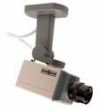
Chandler: Hi, um, I'm account number 7143457. And, uh, I don't know if you got any of that, but I would really like a copy of the tape.
account number n.帐号
End

